**Topics:**

* Adding fractions with like and unlike denominators
* Subtracting fractions with like a unlike denominators
* Subtracting fractions when regrouping is required
* Applying fractions to real world situations

**Practice Questions:**

1. $\frac{3}{5}$ + $\frac{4}{5}$
2. $\frac{8}{10}$ + $\frac{2}{10}$


$\frac{1}{2}+\frac{1}{3}$

$\frac{3}{8}+\frac{4}{9}$

$\frac{5}{7}-\frac{2}{7}$

$\frac{9}{12}-\frac{6}{12}$

$\frac{3}{4}-\frac{1}{3}$

$\frac{4}{6}-\frac{2}{4}$

$\frac{8}{12}-\frac{1}{3}$

$4\frac{2}{3}-3\frac{1}{5}$

$3\frac{2}{7}-\frac{5}{7}$

$5\frac{8}{9}+1\frac{6}{12}$

6. The Smith family is driving to the Outterbanks for a beach trip. The total drive takes 8 ¾ hours. They plan to stop in Richmond, Virginia for lunch which only takes 2 ½ hours to get to. After their stop, how much more driving do they have to do?
7. Shonda’s cookies require 1 ¾ cup of brown sugar and 2 $1/3$ cup of granulated sugar. How much sugar does the recipe call for?
8. Robin and Alexander are pulling weeds in the garden for their parents and putting them in a wheelbarrow. Robin filled the wheelbarrow ¾ of the way and Alexander pulled another 7/8. How full was the wheelbarrow?
9. A pint of ice cream was $9/{10}$ full when Rachel opened it. When she finished, it was ½ way empty. How much ice cream did Rachel eat?
10. Ms. Patel cut 3 $1/2$ inches of wood off a board that was originally 7 $3/4$ inches long. How long was the board after she cut it?
11. 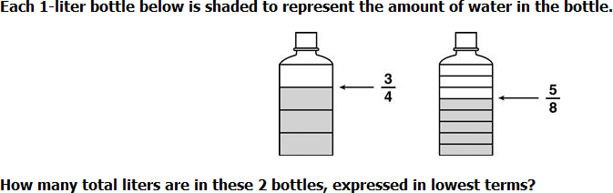
12. Monday morning it rained 1 $5/8$ inches of rain and in the afternoon, it rained another 2 $1/8$ inches of rain. How much rain fell on Monday?
13. Omar measured $5/8$ pounds of flour on a scale. He removed some flour from the scale so that only $3/{16}$ pound was left. How much flour did he remove?