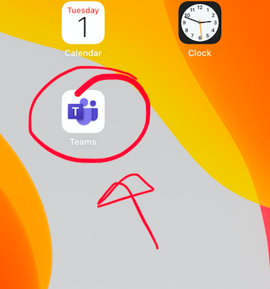
How to Get To Your Homeroom TEAM Meeting - Grade 4

- Look for the Teams app on your iPad and click on it.

- You will see all of your TEAMS listed on the left. Click on your Homeroom Team! 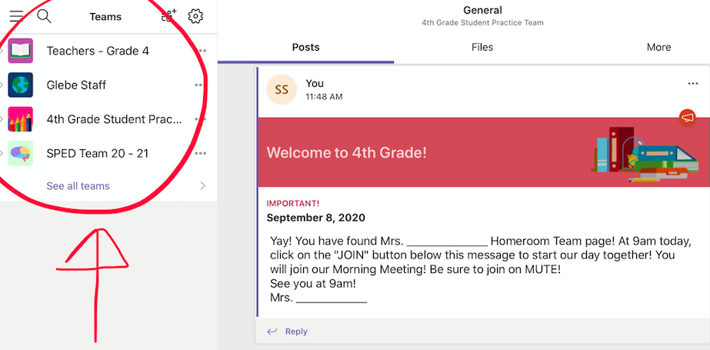

- At 9am, in your homeroom TEAM, you will see the blue “Join” button. Click it and you will be in your meeting!
