**Topics on test:** *Test Thursday, 1/13*

* Rounding decimals to the nearest whole number, tenths, and hundredth place value
* Simplifying fractions
* Representing fractions and decimals in models
* Finding decimal and fraction equivalents
* Comparing and ordering fractions, decimals, and mixed numbers

**Practice Problems:**

*Round the decimal to the underlined digit*

1. 23.321= _________
2. 7.984 = __________
3. 0.561 = __________
4. 21.983 = _________
5. *Name three decimal numbers that when rounded equal 11.6*

*Name the equivalent decimal or fraction*

1. 3/4 = _________
2. 0.375 = _________
3. 6/10 = ________
4. 0.25 = _________
5. 14/20 = _________

*Simplify the fraction to its simplest form by finding the GCF of numerator and denominator and dividing*

1. 8/20 = _________
2. 15/45 = _________
3. 3/12 = _________
4. 75/100 = _________
5. 14/26 = _________

Turn Over

*Shade in the model to represent the given fraction*

|  |
| --- |
| 1. 4/10 Image result for 10x10 chart |
| 1. 12/48Image result for 10x10 chart |

*Name the fraction and decimal the models represent*

1. [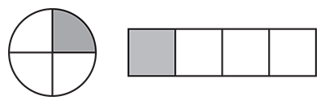](https://www.tes.com/lessons/hxwupifpGgjYWw/fraction-models) Decimal:

Fraction: ________

1. [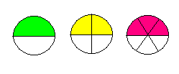](http://www.cpalms.org/Public/PreviewStandard/Preview/539)Decimal: ________

Fraction: ________

*Order the sets from least to greatest*

1. 1/2, 1/3, 3/4, 1/4 __________________________
2. 0.2, 1/4, 0.35, 2/6 _________________________
3. 3 and 3/8, 3.33, 4 and 1/2, 4.25 __________________________

Compare using < > or =

1. 1.567 ______ 1.376
2. 1 and 1/3 ______ 1.33
3. 0.32 ______ 2/3