Name: _________________
Homework 3/15
Directions: Identify each type of angle as acute, obtuse, right or straight.
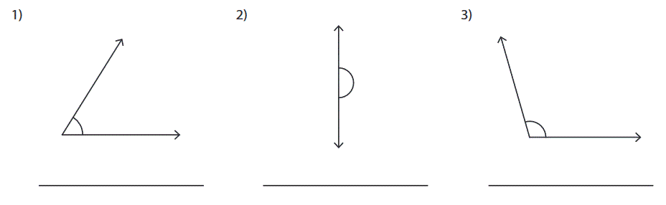
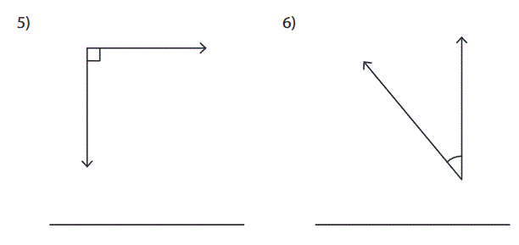
Directions: Use the protractor to find the angle measurement. Try to be as precise as possible!
