Name: _____________
Unit 9 Review Sheet
Test: Friday, April 26
Topics on test:
- Transformations (Translation, Reflection, and Rotation)
- Subdividing and Combining Figures
- Circle
Question 1-3: Circle the correct transformations from column 1 in column 2. Some problems may have more than one answer. Circle all correct answers.
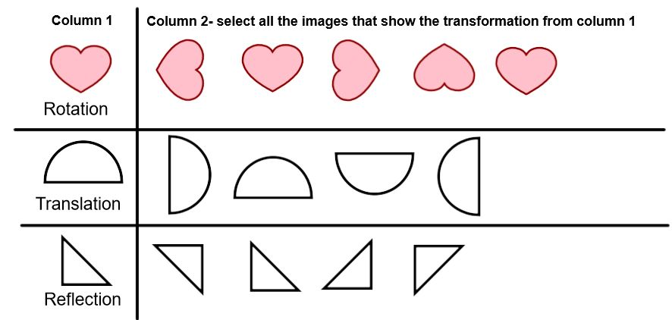
- Looking in a mirror is an example of what type of Transformation? ___________

- Draw a polygon that is symmetrical when folded over a dotted line:

Use this picture to answer question 6 and 7
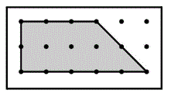
- This shape is a _____________________. Be as specific as possible.
- Draw one line on the polygon on the previous page. The two new polygons are subdivided to create a ____________ and ________________.

- 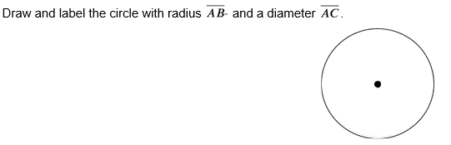

- The circumference of a circle measures 48 inches. What would the radius be? ________ inches.

- If O is the center of the circle, name all the radii. 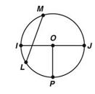_____________

- Use the picture of the circle (below) to answer the question.

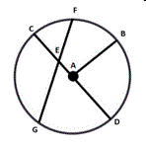 Select all the line segments that would be labeled as a chord.
- AB
- CD
- FG
- CA

