**Name: ______________**

**Unit 3 Test Review- Due Tuesday, January 7**

**Test: Wednesday, January 8**

**Topics on test:**

* 5.CE.3a Rounding Decimals: _________/7 correct
* 5.NS.1abcd Fraction and Decimal Equivalents _________/18 correct

**Standard 5.CE.3a – round decimals to help with estimation strategies when solving single and multistep word problems**

Question 1- 7: ______________

*Round the decimal to the underlined digit*

1. 23.321= _________
2. 7.984 = __________
3. 0.561 = __________
4. 21.983 = _________
5. *Name three decimal numbers that when rounded equal 11.6*
6. Laura and Phillip were driving to Florida for winter break. They chose to split up their trip with a night in Charleston, South Carolina on the way. On day 1 of their trip, they drove 531.5 miles from Arlington to Charleston. On day 2 they drove 379.85 miles from Charleston to Orlando, Florida. Use estimation to determine a reasonable solution for how many miles Laura and Phillip drove to get to Florida.

_____________ miles

1. Circle **all** the numbers that are 34.7 when rounded to the nearest tenths place.

34.71 34.792 34.68 34.732 34.75

**Standard 5.NS.1abcd – identify and represent equivalency between fractions and decimals with or without models; order and compare fractions and decimals**

Question 8 - 25: ______________

*Name the equivalent decimal or fraction*

1. 3/4 = _________ (name the decimal)
2. 6/10 = ________ (name the decimal)
3. 0.25 = _________ (name the fraction)
4. 14/20 = _________ (name the decimal)

*Simplify the fraction to its* ***simplest*** *form by finding the GCF of numerator and denominator and dividing*

1. 8/20 = _________
2. 15/45 = _________
3. 3/12 = _________
4. 75/100 = _________

*Shade in the model to represent the given fraction*

1. 4/10 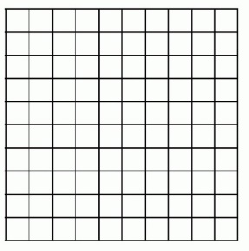 **17)**12/48 (hint: simplify first to help you!) 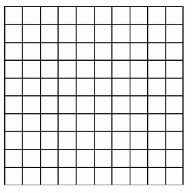

*Name the fraction and decimal the models represent*

1. [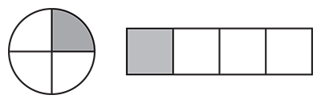](https://www.tes.com/lessons/hxwupifpGgjYWw/fraction-models) Decimal: ________ Fraction: ________
2. [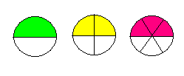](http://www.cpalms.org/Public/PreviewStandard/Preview/539)Decimal: ________ Fraction: ________

*Order the number sets from least to greatest*

1. 1/2, 1/3, 3/4, 1/4 __________________________
2. 0.2, 1/4, 0.35, 2/6 _________________________
3. 3 and 3/8, 3.33, 4 and 1/2, 4.25 __________________________

Compare using < > or =

1. 1.567 ______ 1.376
2. 1 and 1/3 ______ 1.33
3. 0.32 ______ 2/3

Use the space below or on the back to write anything that may be helpful for a brain dump on the test!